An
Industrial Training Project Report on

OEE Monitoring and Production Management System
Submitted in partial fulfilment for the requirements for the degree of

Bachelor of Technology
In
Electronics & Computer Engineering

Submitted by
Avnish Rao (22001015010)

Under the supervision of
Mr. Sanjay Kumar (HOD)



Department of Electronics Engineering Faculty of Engineering and Technology
J.C. Bose University of Science and Technology, YMCA Faridabad, 121006, Haryana
Jan-June, 2026

INTERNSHIP CERTIFICATE

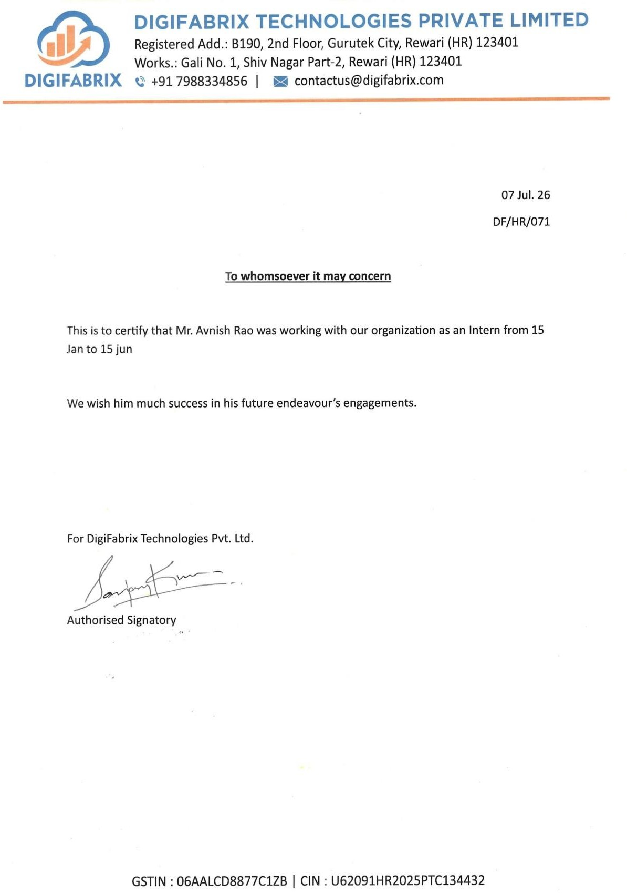

CANDIDATE’S DECLARATION

I hereby certify that the work which is being presented in this project report titled

“OEE MONITORING AND PRODUCTION MANAGEMENT SYSTEM”
submitted to “J.C. BOSE University of Science & Technology, YMCA Faridabad”, is an authentic record of my own work carried out in the company “Digifabrix Technologies Private Limited”. The work contained in this thesis has not been submitted to any other University of Institute.

Student Signature:

Student Name: Avnish Rao

Student Roll No.: 22001015010

EXAMINERS EVALUATION

The project report has been evaluated by us.

Internal Examiner

Signature:

Name:

Designation:

Date:

External Examiner

Signature:

Name:

Designation:

Date:

ACKNOWLEDGEMENT

I would like to express my sincere gratitude to my project guide, company mentor, and faculty members for their continuous guidance and support throughout the internship period.
I am thankful to the Digifabrix Technologies for providing me with an opportunity to work on the OEE Monitoring and Production Management System and gain practical exposure to real-world software development practices.
The experience helped me understand project planning, requirement analysis, web application development, testing procedures, and system deployment concepts.
Finally, I would like to thank my family and friends for their encouragement and support throughout the completion of this project.

Name: Avnish Rao

Roll No.: 22001015010

TABLE OF CONTENTS
Title Page i
Certificate ii
Declaration iii
Examiners Evaluation iv
Acknowledgement v
Table of Contents vi
CHAPTER 1: COMPANY PROFILE
  - Introduction 2
  - About Digifabrix Technologies Pvt. Ltd. 2
  - Vision 3
  - Mission 3
  - Products and Services 3-4
CHAPTER 2: INTRODUCTION TO PROJECT
  - Introduction 6
  - Project Overview 6-7
  - Problem Statement 7
  - Existing System 7-8
  - Proposed System 8
  - Objectives of the Project 8-9
  - Scope of the Project 9
  - Benefits of the System 9-10
CHAPTER 3: Requirement Analysis
  - Introduction 12
  - Software Requirement Specification 12-13
  - Functional Requirements 13-14

  - Non-Functional Requirements 14
  - Software Requirements 14-15
  - Feasibility Study 15
  - User Workflow 15

CHAPTER 4: SYSTEM DESIGN

  - Introduction 17
  - System Architecture 17-18
  - Working of the System 18-19
  - High-Level Design 19-20
  - Module Description 20-21

CHAPTER 5: TECH STACK USED

  - Hardware Technologies 23
  - Backend Technology 23-24
  - Database 24
  - Frontend Technology 24-26

CHAPTER 6: TESTING STRATEGY

  - Introduction 28
  - Testing Objectives 28
  - Types of Testing Performed 28-29
  - Test Cases 29
  - Test Results 29
  - Challenges Faced During Testing 29
  - Benefits of Testing 30

CHAPTER 7: SNAPSHOTS OF GUI
  - Analysis Dashboard 32
  - Hourly Product Monitoring 32
  - Production Summary Dashboard 33
  - Downtime Analysis Report 34

CHAPTER 8: CONCLUSION 36-37

REFERENCES 38

CHAPTER 1 INTRODUCTION



CHAPTER 1 COMPANY PROFILE

Introduction

Industrial automation and digital manufacturing have become essential for improving productivity, reducing downtime, and maintaining product quality in modern manufacturing industries. With the adoption of Industry 4.0 technologies, organizations are increasingly using Industrial Internet of Things (IIoT), automation, and data analytics to monitor production processes in real time.^{[7]}
Digifabrix Technologies is a technology company that specializes in developing digital manufacturing solutions for industries.^{[1}T] he company provides software and hardware solutions that help manufacturers monitor production, improve machine utilization, reduce operational losses, and make data-driven decisions. During my industrial training at Digifabrix Technologies, I worked on an Industrial IoT Based OEE Monitoring and Production Analysis System, which is one of the company's core manufacturing solutions.

About Digifabrix Technologies

Digifabrix Technologies is a digital manufacturing solutions provider that focuses on helping industries transform conventional manufacturing processes into smart and connected production systems. The company develops Industrial IoT applications, production monitoring systems, manufacturing execution systems, and automation solutions for various manufacturing sectors.
Its solutions are designed to provide real-time visibility of production activities, machine performance, manpower utilization, and quality metrics. By combining embedded hardware, cloud technologies, and web-based software, Digifabrix Technologies enables organizations to improve productivity, reduce downtime, and enhance operational efficiency.
The company serves several manufacturing organizations by delivering customized Industry 4.0 solutions that support continuous monitoring and digital transformation.

Vision
To become a trusted technology partner in digital manufacturing by delivering innovative Industry 4.0 and Industrial IoT solutions that improve productivity, quality, and operational excellence.

Mission
- To develop reliable and scalable industrial software solutions.
- To help industries adopt smart manufacturing technologies.
- To improve production efficiency through real-time monitoring and automation.
- To provide data-driven insights for better business decisions.

Products and Services
Digifabrix Technologies offers a wide range of digital manufacturing solutions that help industries improve production efficiency, reduce operational losses, and implement Industry 4.0 technologies. The major products and services offered by the company are described below.

Real-Time Production Monitoring & OEE
The Real-Time Production Monitoring and OEE system is one of Digifabrix Technologies primary solutions for manufacturing industries. It continuously collects production data from industrial machines using ESP32-based OEE modules and displays it on a web dashboard. The system monitors machine availability, production performance, product quality, downtime, and shift-wise production. By calculating Overall Equipment Effectiveness (OEE), industries can easily identify production losses and improve machine utilization.^{[6}T] his solution helps supervisors and plant managers make informed decisions using real-time production data.

Manufacturing Execution System (MES)
The Manufacturing Execution System (MES) is designed to manage and control production activities on the shop floor. It assists in production planning, work order management, production recording, quality inspection, and dispatch monitoring. The system ensures that every stage of the manufacturing process is recorded digitally,

reducing manual paperwork and improving production traceability. MES helps organizations maintain better control over production operations while increasing overall manufacturing efficiency.

DOJO 2.0 – Advanced Manpower Planning & Management
DOJO 2.0 is an intelligent workforce management solution developed to improve manpower planning and employee productivity. It provides features such as attendance management, shift mapping, skill matrix management, employee training records, and productivity analysis. The system enables organizations to allocate human resources more effectively and monitor workforce performance in real time. It also assists management in making better decisions regarding manpower utilization and operational planning.

End-to-End Traceability
The End-to-End Traceability solution enables manufacturers to track products throughout the complete production process. Using barcode and QR code technologies, every product can be traced from raw material to the finished product stage. The system records serial numbers, process information, inspection details, and production history, making it easier to identify defects and maintain complete production records. This feature is particularly useful for industries that require strict quality control and regulatory compliance.

Barcode & Automation Solutions
Digifabrix Technologies offers barcode and automation solutions that simplify data collection and inventory management in manufacturing industries. The system supports barcode scanner integration, label printing, API connectivity, and ERP integration. These solutions eliminate manual data entry, improve production accuracy, and ensure faster information flow between different departments. Barcode automation also helps maintain accurate production records and improves overall process efficiency.

CHAPTER 2 INTRODUCTION TO PROJECT

CHAPTER 2 INTRODUCTION TO PROJECT

Introduction
In today's manufacturing industry, maintaining high productivity while minimizing downtime is a major challenge. Traditional methods of monitoring production often rely on manual record keeping, which can lead to delays, inaccurate data, and limited visibility of machine performance. As industries adopt Industry 4.0 technologies, there is an increasing demand for smart monitoring systems that provide real-time information about production activities.
The Industrial IoT Based OEE Monitoring and Production Analysis System developed at Digifabrix Technologies addresses these challenges by combining embedded hardware, Industrial IoT, and web technologies. The system collects live production data from machines using ESP32-based OEE modules and displays it on a centralized dashboard. It enables production supervisors and management teams to monitor machine status, production targets, downtime, quality, and Overall Equipment Effectiveness (OEE) from a single platform.
The project provides real-time insights into manufacturing operations, helping industries improve productivity, identify production losses, and make informed decisions.

Project Overview
The Industrial IoT Based OEE Monitoring and Production Analysis System is a web-based industrial monitoring solution designed to collect, process, and visualize production data from manufacturing machines.
The system uses an ESP32 microcontroller connected to industrial machines for collecting production-related data such as machine status, production count, downtime events, and cycle information. The collected data is transmitted to a PHP-based backend, where it is processed and stored in a MySQL database. The frontend dashboard retrieves this information and presents it in the form of graphs, tables, reports, and real-time indicators.
The application allows users to monitor multiple production lines simultaneously and provides detailed reports for machine performance, production quantity, quality, downtime, and shift-wise analysis.

The major dashboards developed in the project include:
    - Analysis Dashboard
    - Production Summary Dashboard
    - Shift Hourly Analysis Dashboard
    - Production Reports
    - Downtime Analysis
    - Speed Loss Report
    - Production Quantity Report
    - Machine Time Usage Report
These dashboards provide complete visibility into factory operations and assist management in improving production efficiency.

Problem Statement
Many manufacturing industries still depend on manual methods for recording production data and machine performance. Operators prepare production reports manually after every shift, which is a time-consuming process and often results in delayed or inaccurate information.
Some of the common problems faced in traditional production monitoring systems include:
    - Manual recording of production data.
    - Difficulty in identifying machine downtime.
    - Lack of real-time production monitoring.
    - Delayed management reporting.
    - Poor visibility of machine performance.
    - Difficulty in calculating OEE accurately.
    - Limited access to historical production data.
Due to these limitations, production managers are unable to identify losses quickly, resulting in reduced productivity and inefficient utilization of manufacturing resources.

Existing System
In the existing production monitoring system, operators manually record machine output, downtime, and production details in logbooks or spreadsheets. Production reports are prepared at the end of each shift, making it difficult to monitor machine performance in real time.

The existing system has several limitations:
    - Manual data entry increases the possibility of human errors.
    - Production data is not available in real time.
    - Machine downtime is difficult to track accurately.
    - OEE calculations require manual effort.
    - Historical reports are difficult to maintain.
    - Decision-making becomes slow due to delayed information.
    - There is no centralized dashboard for monitoring multiple machines.
As a result, industries face challenges in improving productivity and reducing operational losses.

Proposed System
To overcome these limitations, Digifabrix Technologies developed an Industrial IoT Based OEE Monitoring and Production Analysis System.
In this system, each production machine is connected to an ESP32-based OEE module, which continuously monitors machine signals and production counts. The ESP32 transmits production data over the network to the backend server.
The backend application, developed using PHP, processes the incoming data and stores it in a MySQL database. The frontend dashboard retrieves this information and displays it in an easy-to-understand format using graphs, charts, progress bars, and statistical reports.
The proposed system enables users to:
    - Monitor production in real time.
    - View machine status (Running, Idle, Stopped).
    - Track hourly production.
    - Calculate Overall Equipment Effectiveness (OEE).
    - Monitor product quality.
    - Generate production reports.
    - Analyze machine downtime.
    - Compare production across different shifts.
The proposed solution significantly improves production monitoring and supports data-driven decision-making.

Objectives of the Project

The main objectives of the project are:
    - To monitor industrial machines in real time.
    - To automate production data collection.
    - To calculate Overall Equipment Effectiveness (OEE).
    - To reduce manual production reporting.
    - To monitor machine downtime and idle time.
    - To improve production quality.
    - To generate production reports automatically.
    - To improve decision-making using real-time analytics.
    - To support Industry 4.0 implementation in manufacturing industries.

Scope of the Project
The scope of this project includes monitoring industrial machines connected to ESP32-based OEE modules through a web-based dashboard.
The system can be used in manufacturing industries for:
    - CNC machine monitoring.
    - Production line monitoring.
    - Shift-wise production analysis.
    - Machine utilization analysis.
    - Downtime monitoring.
    - OEE calculation.
    - Quality monitoring.
    - Historical production reporting.
    - Production planning and analysis.
The system can also be expanded in the future by integrating cloud services, predictive maintenance, AI-based production analysis, mobile applications, and ERP systems.

Benefits of the System
The implementation of the OEE Monitoring System provides several advantages to manufacturing industries.
Some of the major benefits include:
    - Real-time production visibility.
    - Improved machine utilization.

    - Reduction in manual paperwork.
    - Faster identification of machine downtime.
    - Accurate OEE calculation.
    - Better production planning.
    - Improved quality monitoring.
    - Centralized production dashboard.
    - Historical report generation.
    - Better decision-making through production analytics.

CHAPTER 3 REQUIREMENT ANALYSIS

Introduction

CHAPTER 3 REQUIREMENT ANALYSIS

Requirement Analysis is one of the most important phases in software development. During this phase, the requirements of the system are identified, analyzed, and documented before the actual development begins. A proper requirement analysis helps developers understand the system's objectives, user needs, and technical requirements. For the Industrial IoT Based OEE Monitoring and Production Analysis System, the requirement analysis focused on understanding the workflow of manufacturing industries, the production monitoring process, and the type of information required by machine operators, supervisors, and management. Based on these requirements, a web-based monitoring system was designed to provide real-time production data, machine status, and analytical reports.

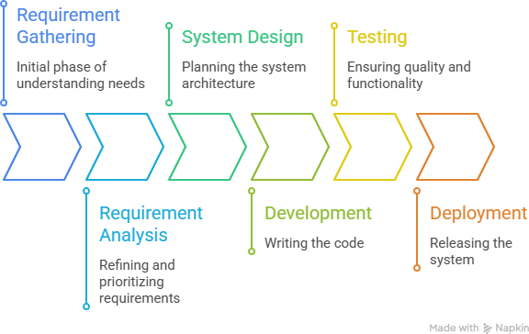

Figure-3.1 Requirement Analysis Flow

  - Software Requirement Specification (SRS)
The Software Requirement Specification (SRS) defines the functional and technical requirements of the system. It acts as a blueprint for developing the application and ensures that the final system meets user expectations.
The OEE Monitoring System was designed to provide real-time production monitoring, machine status tracking, downtime analysis, and production reporting through an easy-

to-use web interface.
The system mainly consists of the following modules:
    - Machine Monitoring
    - OEE Calculation
    - Production Dashboard
    - Shift Analysis
    - Production Reports
    - Downtime Analysis
    - User Authentication
    - Database Management

Functional Requirements
Functional requirements describe the operations that the system must perform. The OEE Monitoring System should be able to:

User Login
The system should allow authorized users to securely log in and access the dashboard according to their roles.

Machine Monitoring
The system should continuously monitor the status of connected machines and display whether the machine is Running, Idle, or Stopped.

Production Monitoring
The system should display the total production count, hourly production, production targets, and production progress in real time.

OEE Calculation
The application should automatically calculate Overall Equipment Effectiveness (OEE) using Availability, Performance, and Quality values.

Quality Monitoring
The system should display the number of accepted and rejected products and calculate the quality percentage.

Downtime Analysis
The system should record downtime events, their duration, and reasons, helping industries identify major production losses.

Report Generation
Users should be able to generate production reports for Today, Yesterday, This Week,

Last Week, Last Month, and Custom Date Range.

Dashboard Visualization
The application should present production information using graphs, charts, progress bars, and summary cards for better understanding.

Non-Functional Requirements
Non-functional requirements describe the quality and performance characteristics of the system.

Performance
The system should display production data with minimal delay and refresh dashboards efficiently.

Reliability
The application should accurately store production data without loss and maintain consistent system performance.

Security
Only authorized users should be allowed to access production information using secure login credentials.

Scalability
The system should support the addition of new machines, production lines, and users without major changes to the application.

Availability
The dashboard should be accessible whenever the production system is operational, allowing users to monitor machines continuously.

Software Requirements
The software used for developing and running the project is given below.

Software | Purpose
PHP | Backend Development
MySQL | Database Management
HTML | Page Structure
CSS | User Interface Design
Bootstrap | Responsive Layout

JavaScript | Dynamic Functionality
AJAX | Real-time Data Loading
Chart.js | Data Visualization
Apache (XAMPP) | Local Server
Visual Studio Code | Code Editor

Feasibility Study
Before developing the project, a feasibility study was conducted to determine whether the system could be implemented successfully.

Technical Feasibility
The required technologies such as ESP32, PHP, MySQL, HTML, CSS, JavaScript, and Industrial IoT devices were available and suitable for implementing the project.

Operational Feasibility
The proposed system is easy to operate and provides real-time production information through a simple dashboard. Operators and supervisors can use the application with minimal training.

Economic Feasibility
The use of ESP32 microcontrollers and open-source software technologies reduces the overall development cost. The improvement in production efficiency also helps industries recover implementation costs over time.

User Workflow
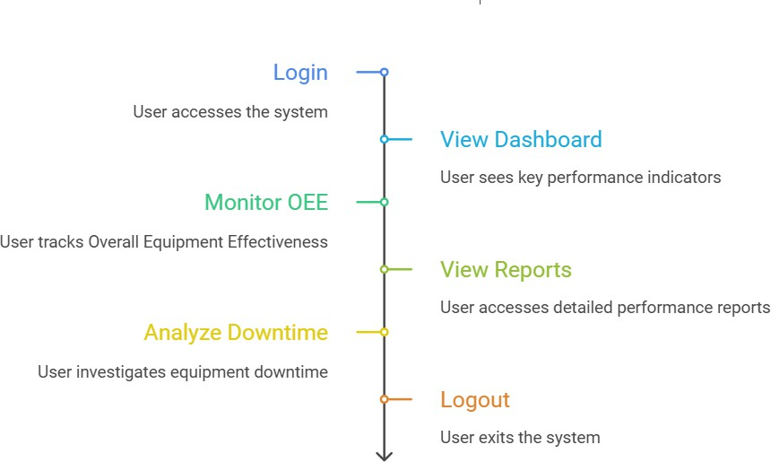

Fig 3.7 User Workflow

CHAPTER 4 SYSTEM DESIGN

  - Introduction

CHAPTER 4 SYSTEM DESIGN

System design is the process of defining the architecture, components, modules, database, and data flow of a software system before implementation. A well-designed system ensures smooth communication between hardware and software components while maintaining scalability, reliability, and ease of maintenance.
The Industrial IoT Based OEE Monitoring and Production Analysis System is designed using a client-server architecture. The system integrates ESP32-based OEE modules with a PHP backend, MySQL database, and a web-based dashboard. Production data collected from industrial machines is processed by the backend and displayed to users in the form of real-time dashboards, reports, and analytical charts.
The system is capable of monitoring multiple production lines simultaneously and provides complete visibility of machine performance and production activities.

System Architecture
The architecture of the system consists of five major components:
- Industrial Machine
- ESP32 OEE Module
- PHP Backend Server
- MySQL Database
- Web Dashboard
The overall workflow begins with the industrial machine generating production signals. These signals are captured by the ESP32 microcontroller through sensors connected to the machine. The ESP32 processes the information and transmits it over the network to the backend server.
The PHP backend receives the incoming data, validates it, performs OEE calculations, and stores the processed information in the MySQL database. The frontend dashboard then retrieves this data and displays production statistics, machine status, quality information, and reports in real time.

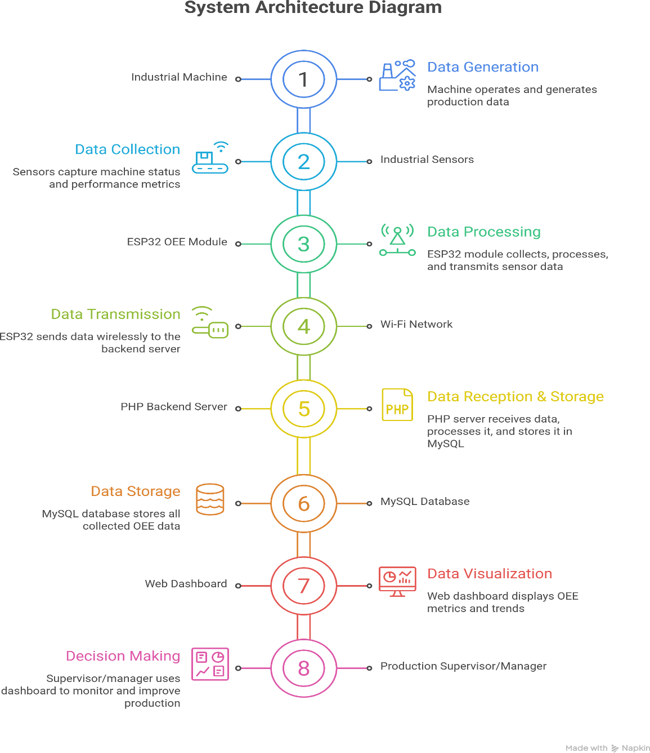

Fig 4.2 System Architecture Diagram

  - Working of the System
The working of the OEE Monitoring System can be divided into several stages. Initially, sensors installed on industrial machines detect machine activity, production count, and machine status. These signals are transmitted to the ESP32 microcontroller, which acts as the data acquisition unit.
The ESP32 processes the collected information and sends it to the PHP backend through

the network. The backend validates the incoming data and stores it in the MySQL database.^{[4]}
The system automatically calculates various production parameters such as:
- Machine Availability
- Production Performance
- Product Quality
- Overall Equipment Effectiveness (OEE)
The dashboard continuously retrieves updated information from the database and displays it in graphical form, allowing supervisors to monitor production in real time. Whenever production data changes, the dashboard reflects the updated values without requiring manual intervention.

High-Level Design
The system is divided into different layers, where each layer performs a specific function.

Presentation Layer
The presentation layer consists of the web dashboard developed using HTML, CSS, Bootstrap, JavaScript, and Chart.js.^{[5]}It displays production statistics, machine status, OEE values, reports, and graphical analysis.

Business Logic Layer
The business logic layer is developed using PHP.^{[3}I]t processes machine data, calculates OEE values, validates incoming information, manages user authentication, and generates reports.

Database Layer
The database layer uses MySQL for storing production records, machine details, downtime information, quality data, and user information.

Hardware Layer
The hardware layer includes industrial machines, sensors, and ESP32 microcontrollers responsible for collecting real-time production data.

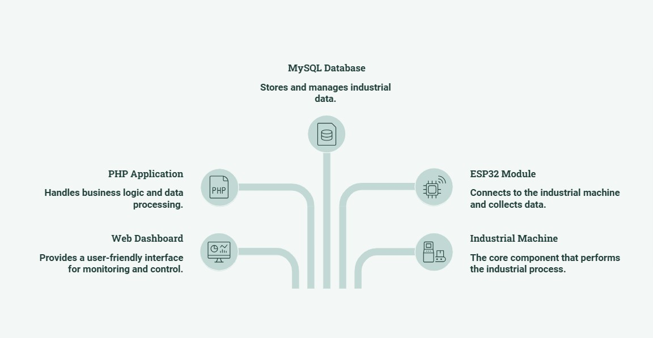

Fig 4.4 High Level Design

  - Module Description
The system is divided into several functional modules.

Login Module
This module authenticates users before allowing access to the dashboard. Different users can log in using their credentials.

Analysis Dashboard
This module displays:
  - Production Plan
  - OEE
  - Availability
  - Performance
  - Quality
  - Hourly Production
  - Last Hour Production
  - Machine Status
The dashboard provides real-time visibility into machine performance.

Production Summary Dashboard

This module provides an overview of all machines connected to the system. It displays:
  - Working Machines
  - Idle Machines
  - Stopped Machines
  - Overall Status Summary
  - Machine Cards
This dashboard helps supervisors monitor multiple production lines simultaneously.

Shift Hourly Analysis
This module provides shift-wise production analysis. It displays:
  - Hourly Machine Status
  - Running Time
  - Idle Time
  - Breakdown Time
  - Hourly Production
  - Rejection Count
This helps identify production losses during different shifts.

Production Reports
The reporting module generates historical production reports. Reports include:
  - Downtime Analysis
  - Speed Loss
  - Production Quantity
  - Machine Time Usage
  - Custom Date Reports
These reports support management in making production-related decisions.

CHAPTER 5 TECH STACK USED

CHAPTER 5 TECH STACK USED

Hardware Technologies
    - ESP32 Microcontroller
The ESP32 is the primary hardware component used in the OEE Monitoring System. It acts as the data acquisition device by collecting signals from industrial machines and transmitting them to the server through a Wi-Fi network.
The ESP32 offers built-in wireless communication, low power consumption, and high processing capability, making it suitable for Industrial IoT applications.^{[2}I]t continuously monitors machine status, production count, and operational events and sends the collected information to the backend for further processing.

Features:
      - Built-in Wi-Fi connectivity
      - Fast processing speed
      - Low power consumption
      - GPIO support for industrial sensors
      - Suitable for Industrial IoT applications

Industrial Sensors
Industrial sensors are connected to the machines to detect production activities such as machine running status, idle condition, production count, and downtime events. These sensors generate signals that are read by the ESP32 module.
The accuracy of the monitoring system largely depends on the reliability of these sensors, as they provide the real-time data required for OEE calculation and production analysis.
  - Backend Technology

PHP

PHP is used as the backend programming language for the development of the web application. It receives production data from the ESP32 modules, processes the information, performs business logic, and stores the records in the MySQL database.

The backend also manages user authentication, report generation, dashboard updates, and communication between the database and the frontend interface.

Why PHP?

      - Easy integration with MySQL

      - Fast server-side processing

      - Open-source and widely used

      - Suitable for web-based applications

      - Easy maintenance

Database

    - MySQL

MySQL is used as the database management system for storing production-related information. It maintains records of machine status, production count, OEE values, downtime details, user information, and generated reports.
The database enables efficient storage, retrieval, and management of production data while ensuring data consistency and reliability.

Data Stored in the Database

      - Machine Details

      - Production Records

      - OEE Data

      - Downtime Logs

      - User Information

      - Shift Details

      - Report Data

  - Frontend Technologies

HTML
HTML is used to create the structure of the web application. It defines the layout of dashboards, tables, forms, navigation menus, and other interface components.

CSS
CSS is used to improve the appearance of the application by defining colors, fonts, spacing, and responsive layouts. It ensures that the dashboard remains visually organized and easy to understand.

5.5.3 Bootstrap
Bootstrap is used for developing responsive user interfaces. It provides pre-designed components such as cards, tables, buttons, navigation bars, and grid layouts that help create a professional-looking dashboard.
The responsive design allows users to access the dashboard on different screen sizes without affecting usability.

JavaScript
JavaScript is responsible for adding interactivity to the application. It handles user actions, updates dashboard elements dynamically, validates forms, and improves the overall user experience.

AJAX
AJAX (Asynchronous JavaScript and XML) enables the dashboard to retrieve updated production data from the server without refreshing the entire webpage. This helps display real-time production information smoothly and improves application performance.

Chart.js
Chart.js is used to present production data graphically. It generates bar charts, line graphs, and pie charts that help users analyze OEE, production trends, downtime, and machine performance more effectively.

Advantages of the Selected Tech Stack
The selected technologies provide several advantages for developing an Industrial IoT application.
Some of the major advantages are:
- Cost-effective implementation using open-source technologies.

- Real-time communication between machines and the server.
- Easy maintenance and future scalability.
- Responsive and user-friendly dashboard.
- Efficient database management.
- Reliable data storage and processing.
- Interactive graphical reports for production analysis.
- Easy integration with Industrial IoT hardware.

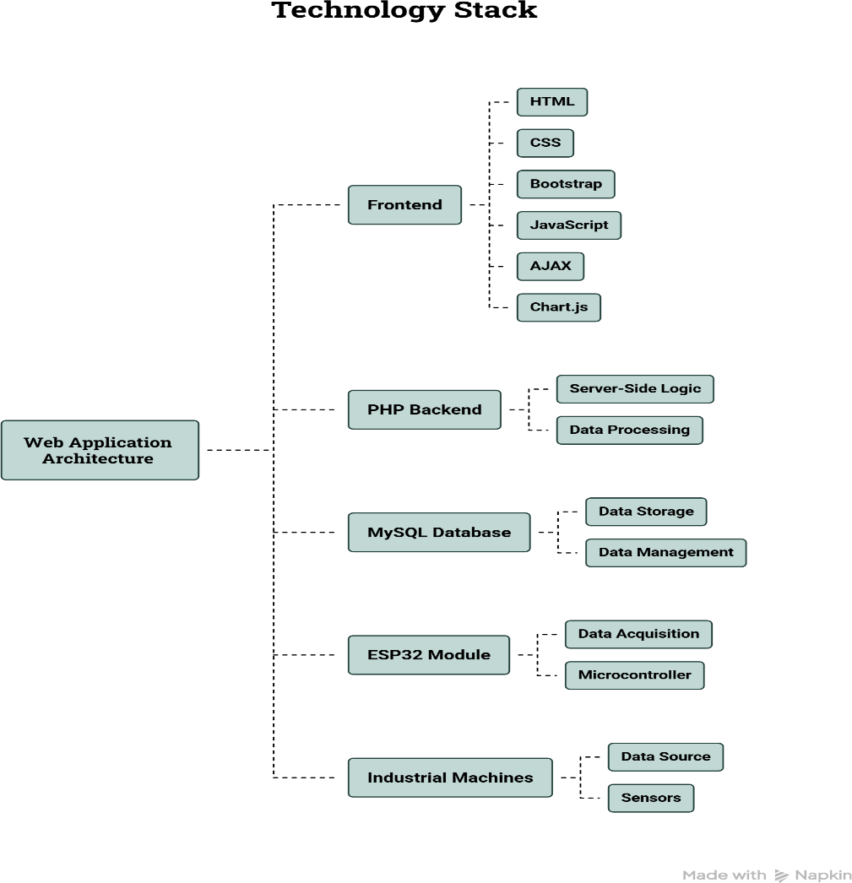

Fig 5.5 Technology Stack Overview

CHAPTER 6 TESTING STRATEGY

  - Introduction

CHAPTER 6 TESTING STRATEGY

Testing is an important phase in the software development life cycle that ensures the developed application works correctly and meets the specified requirements. It helps identify errors, improve system reliability, and verify that every module performs as expected.
The testing was carried out to verify the accuracy of production data, dashboard functionality, report generation, user authentication, and communication between the ESP32 module, backend server, and database. The objective was to ensure that the application provides reliable and real-time production monitoring.

Testing Objectives
The main objectives of testing the OEE Monitoring System were:
- To verify that all system modules work correctly.
- To ensure accurate display of production and OEE data.
- To validate communication between ESP32 and the backend server.
- To verify correct storage and retrieval of data from the MySQL database.
- To ensure reports are generated accurately.
- To identify and resolve functional issues before deployment.

Types of Testing Performed
    - Unit Testing
Unit testing was performed on individual modules such as the login page, dashboard components, report generation, and database operations. Each module was tested independently to ensure it produced the expected output.

Integration Testing
Integration testing verified the interaction between different components of the system. The communication between the ESP32 module, PHP backend, MySQL database, and web dashboard was tested to ensure smooth data flow without any interruption.

System Testing
System testing was carried out on the complete application after integrating all modules. The overall functionality, including production monitoring, OEE calculation,

dashboard updates, and report generation, was verified under different operating conditions.

User Interface Testing
The graphical interface was tested to ensure that all dashboards, charts, tables, filters, and navigation menus displayed information correctly. Different screen resolutions and browsers were also checked to maintain a consistent user experience

Database Testing
Database testing ensured that production data received from the ESP32 modules was stored correctly in the MySQL database. Data retrieval, report generation, and historical records were also verified for accuracy and consistency.

Test Cases

Test Case | Expected Result | Status
User Login | User logs in with valid credentials | Passed
Dashboard Loading | Dashboard displays production data | Passed
Machine Status | Running, Idle, and Stopped status shown correctly | Passed
OEE Calculation | OEE calculated accurately | Passed
Production Count | Production count updated correctly | Passed
Report Generation | Reports generated for selected dates | Passed
Database Update | Production data stored successfully | Passed
Logout | User logged out securely | Passed

Test Results
The application performed successfully during testing. All major functionalities, including production monitoring, dashboard visualization, report generation, and database operations, worked as expected. The system was able to receive machine data, process it, calculate OEE values, and display the information on the dashboard without significant delays.
Minor interface improvements and layout adjustments were identified during testing and were resolved before the final deployment. Overall, the application met the functional requirements and demonstrated stable performance during the testing phase.

Challenges Faced During Testing
During the testing process, a few practical challenges were encountered:
- Ensuring stable communication between the ESP32 module and the server.

- Validating the accuracy of production data received from machines.
- Synchronizing real-time dashboard updates with the latest database records.
- Handling temporary network interruptions during data transmission.
- Verifying report accuracy for different date ranges and production shifts. These issues were analyzed and resolved through repeated testing and validation.

Benefits of Testing
Testing played an important role in improving the quality of the application. It helped in:
- Detecting functional errors before deployment.
- Improving data accuracy.
- Ensuring reliable communication between hardware and software.
- Verifying real-time dashboard updates.
- Increasing the stability and reliability of the overall system.

CHAPTER 7 SNAPSHOTS OF GUI

CHAPTER 7 SNAPSHOTS OF GUI

Analysis Dashboard
It provides real-time production information for the selected production line. Important performance indicators such as Production Plan, OEE, Average Hourly Production, Last Hour Output, and Quality are displayed on a single screen, allowing supervisors to monitor machine performance efficiently.
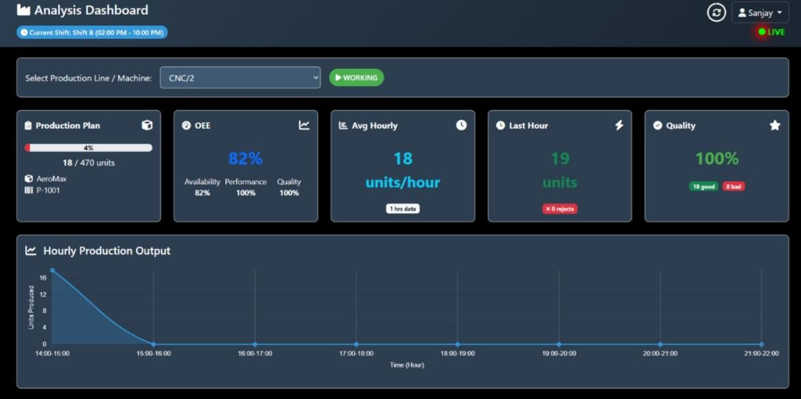

Fig 7.1 Analysis Dashboard
  - Hourly Production Monitoring
This dashboard provides a detailed hour-wise view of machine activity during the selected shift.
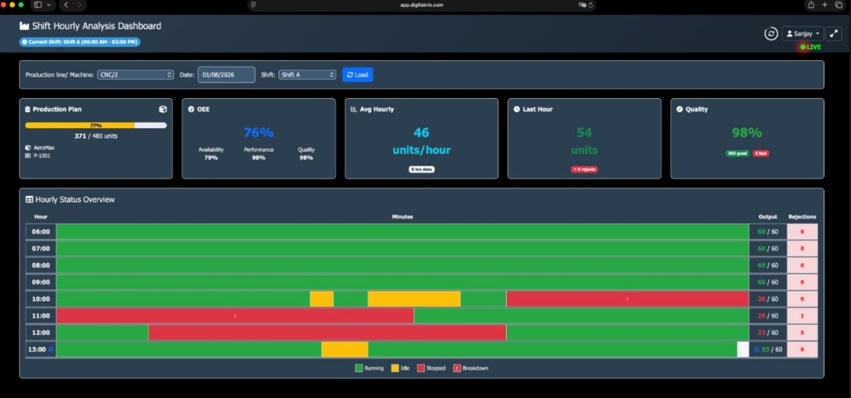

Fig 7.2 Shift Hourly Analysis Dashboard

  - Production Summary Dashboard
The Production Summary Dashboard displays the overall status of all production machines.
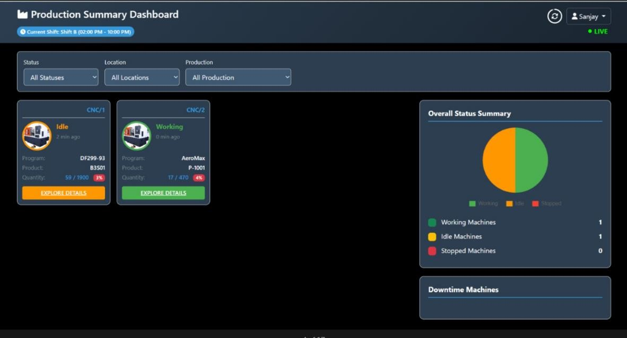

Fig 7.3 Production Summary Dashboard

  - Downtime Analysis Report
The Downtime Analysis Report categorizes machine downtime into different groups such as Technical Issues, Maintenance, Setup, and Work Arrangement.

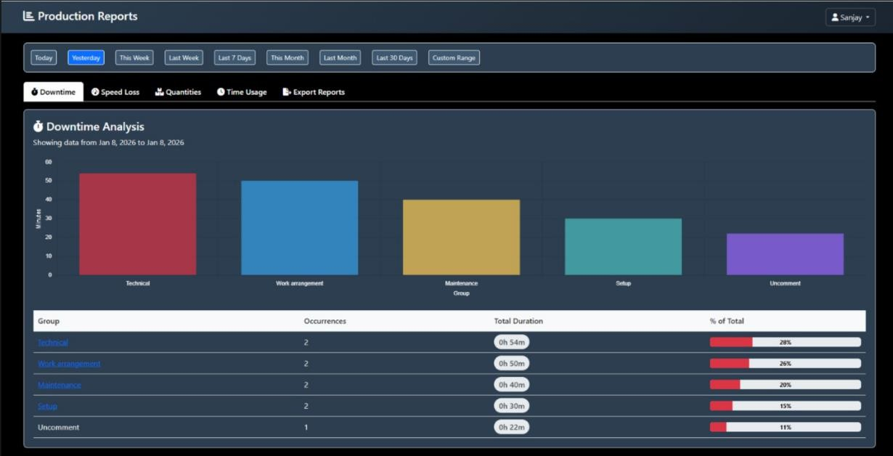

Figure 7.4 Downtime Analysis Report

CHAPTER 8 CONCLUSION

CHAPTER 8 CONCLUSION

During my industrial training at Digifabrix Technologies, I had the opportunity to understand and work on a real-time OEE Monitoring and Production Management System used in manufacturing industries. Throughout the internship, I gained practical exposure to Industry 4.0 concepts, industrial automation, production monitoring, and data-driven decision-making. Working with live manufacturing data helped me understand how software solutions improve operational efficiency, machine utilization, and production quality in modern industries.

Key Accomplishments
- Studied the complete workflow of a real-time OEE Monitoring System used in manufacturing industries.
- Understood the implementation of machine monitoring, production tracking, quality monitoring, and downtime analysis.
- Learned how production data is collected using ESP32 devices and processed through industrial software applications.
- Gained practical knowledge of real-time dashboards used for monitoring production performance and machine status.
- Understood the reporting system used for analyzing production quantity, downtime, and quality performance.
- Observed the integration of hardware devices, databases, and web applications to build a complete manufacturing solution.
The most valuable learning during the internship was understanding how software applications are used in smart manufacturing to monitor production activities in real time. The project demonstrated how technologies such as Industrial IoT, databases, and web-based dashboards work together to improve productivity, reduce downtime, and support data-driven decision-making on the shop floor.

Technical Growth
- Gained knowledge of Overall Equipment Effectiveness (OEE) and its key components: Availability, Performance, and Quality.
- Learned the practical use of ESP32, SQL Database, PHP Backend, and web-based dashboard technologies.
- Understood the flow of real-time production data from industrial machines to the monitoring dashboard.
- Improved my understanding of database management, production reporting, and data visualization.
- Learned how manufacturing dashboards are designed to monitor machine efficiency and production performance.

Professional Growth
- Improved my analytical and problem-solving skills by understanding real industrial workflows.
- Learned to work in a professional environment while following industry standards and project documentation practices.
- Enhanced my communication and teamwork skills by interacting with mentors and industry professionals.
- Developed a better understanding of software development life cycle and industrial project execution.
- Gained confidence in applying classroom concepts to solve practical industrial problems.

REFERENCES

- Digifabrix Technologies Technologies Pvt. Ltd. Official Website. Available at: https://www.Digifabrix Technologies.com
- Espressif Systems. ESP32 Programming Guide. Available at: https://docs.espressif.com
- PHP Documentation. Available at: https://www.php.net/docs.php
- MySQL Documentation. Available at: https://dev.mysql.com/doc
- MDN Web Docs. HTML, CSS and JavaScript Documentation. Available at: https://developer.mozilla.org
- OEE Foundation. Overall Equipment Effectiveness (OEE). Available at: https://www.oee.com
- IBM. Industry 4.0 and Smart Manufacturing. Available at: https://www.ibm.com/topics/industry-4-0

BREIF PROFILE OF STUDENT

Student Name: Avnish Rao

Roll No: 22001015010

Course: Bachelors of Technology (B.Tech)

Branch: Electronics and Computer Engineering (2022-2026)

Email Address: avnishrao1122@gmail.com

Phone No.(M): +91 8076555234

Project Title : OEE Monitoring and Production Analysis System

Company Name: Digfabrix Technologies Private Limited

